**WELCOME!**

I am delighted to welcome you as a new member of the American Society for Clinical Laboratory Science (ASCLS). The ASCLS has been serving the clinical laboratory community for 82 years and looks forward to extending that service to you, one of our newest members. You have joined an organization of nearly 9,000 colleagues who share similar backgrounds, issues, hopes and dreams.

A link on the ASCLS webpage has been designed especially for you! Go to <http://www.ascls.org/new-member-welcome> to find a wealth of information to help you get the most out of your membership.

Your ASCLS membership card is available to print from the website. Please review it for accuracy and notify the membership department at the National Office at 571-748-3770 or [ascls@ascls.org](mailto:ascls@ascls.org) if a correction is necessary.

The Board of Directors and staff of ASCLS are ready to assist you in any way possible, as well as to listen to your comments and suggestions. We urge you to take an active role within the Society. Joining is just the first step toward a better future -- for you and the profession! It’s when you become active that you experience the benefits of networking. We look forward to having you as a valued professional colleague.

Sincerely,

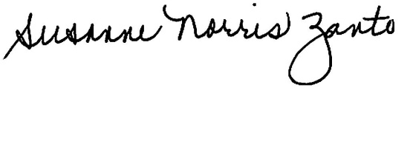

Susanne Norris Zanto, MPH, MLS(ASCP)CM, SM(NRCM)

President, 2014-2015