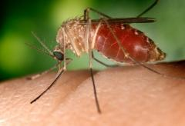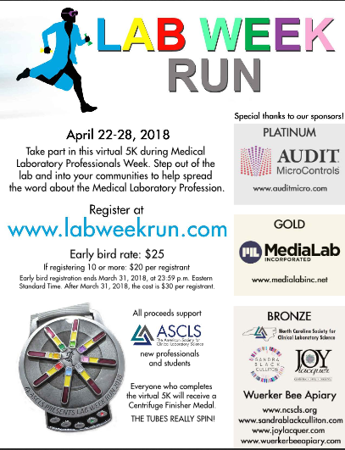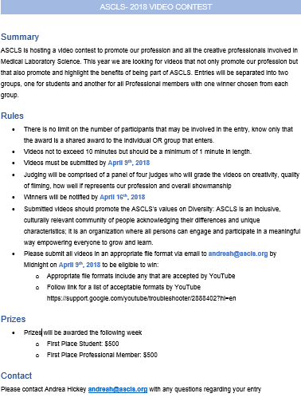

A Legislative Attendee For Life

By: Cherika Robertson

2018 Legislative Symposium

By: Lacy Faulk

National Meeting 2018

Imagine walking into the lab to start your shift only to be told that a CSF you had analyzed a few days prior had been collected from a patient with a unique pathogen and that new precautions were being taken with subsequent samples. That could trigger a lot of questions regarding what it would mean if someone hadn’t followed these special protocols with the previous sample. I started to ask about this and learned more than I would ever need to know about exposure to the uncommon pathogen, Eastern Equine Encephalitis virus.

First, some backstory on this patient with this rare infectious disease. Somewhere at an outside facility multiple transplants were taking place at the same time with organs from one donor. One of the transplant recipients made it to our facility where this patient had begun to reject the organ. On top of that, it had been discovered that the organ donor had been infected with Eastern Equine Encephalitis virus (EEEV). Due to a communication breakdown, that information did not make it to our lab for quite some time after the patient had been admitted. It is still unknown to the lab how long the floor staff had been also working without any extra precautions.

After we were informed of this patient’s potential diagnosis, we were educated about what the virus is and what physiological manifestations it can have. For anyone not familiar with this virus, Eastern Equine Encephalitis Virus (EEEV) is a member of the genus *Alphavirus* and the family *Togaviridae*. Its genome is composed of single-stranded RNA; additionally, it is spherical shaped, enveloped, and is about 60-65 nm in diameter. EEEV is transmitted to humans primarily by the bite of a mosquito, most notably *Culiseta melanura* since it feeds almost exclusively on birds, which are considered hosts. Horses are particularly susceptible to EEEV infections, but they are not often sources of transmission due to being “dead-end” hosts like humans. EEEV is more prevalent on the east coast of the US and is particularly common in swampy and damp areas where mosquitos like to live.

Infection can take two forms, passive and severe. The passive form is usually asymptomatic and the infected person builds a potentially life-long immunity to the virus. The severe form, more common in the elderly, children, and immunocompromised, is far less common and effects 4-5% of those infected. The severe form is usually the form referred to as Eastern Equine Encephalitis. The severe form is further broken down into systemic and encephalitic infections. After a 4-10 day incubation period the systemic form begins with generic flu/cold like symptoms. For those that progress into the encephalitic form, it can occur a few days after the beginning of the systemic form. It has generic symptoms characteristic of encephalitis/meningitis. Patients that make it to the encephalitic phase are guaranteed brain damage, and about 35% die. There are not any specific symptoms that definitively lead to diagnosis but looking at the clinical picture in its entirety can help narrow it down.

For this particular case, on the day this patient was admitted I was assigned to the body fluids bench and I started working up a CSF that had arrived. We received tubes 1 and 3 as we usually do and I noticed that they were both extremely bloody. Tube 3 was significantly bloodier than tube 1 which raised a yellow flag for me; however, I didn’t think anything of it since we didn’t have any known reason to implement special precautions as we would in the case of BALs, CJD specimens, or other unique pathogens. I performed the required testing and went on to the next one, not batting an eye. It wasn’t until a few days later that we were informed of the EEEV situation. I immediately thought back to the CSF samples I ran and whether I should’ve taken more precautions. My lab instituted safety protocols in the form of sample isolation, double gloving, disposing of all PPE, and sanitizing after testing. All centrifuges used for these samples were placed under our hood to protect from aerosols. Needless to say, all these safety protocols had me worrying a lot: Had I been exposed? What would that mean?

There was a lot of outrage about the delay in notification as people had been working with this sample and thought they were potentially exposed. In response to this, Pathologists, Epidemiologists, Safety officers, and the Laboratory managers got together to figure out if exposure was likely and what the risks of transmission were. They determined that, under normal and safe lab operation, there was little to no risk of transmission and that those who made it past the incubation period did not have anything to worry about. This didn’t really alleviate my, nor anyone else’s, concern so I went to speak to one of the Pathologists about it. He explained that CDC guidelines recommend only standard precautions for patients admitted with the virus as transmission usually requires a vector (except in transfusion and organ transplantation). After hearing this information and inquiring further about the excessive precautions we were having to implement for a supposedly untransmissible virus it was explained that management had made decisions to keep people as safe as possible with the little information we had been given. Also, they explained that it wasn’t certain that the patient had contracted the virus, just that the organ they received had been contaminated with it.

After the patient’s care had concluded and we were no longer receiving their samples, our Epidemiology department held a forum where people could pose any further questions. Once all of our concerns were addressed they focused on how to deal with similar occurrences in the future. Communication between facilities is key, especially when patients are transferred without complete medical records or histories. The second, equally important, lesson learned is the need to have a phone tree for this type of event. The hospital didn’t have an organized way to notify relevant departments, and there isn’t time for them to figure out all the departments that need to know. The most important thing that the lab took from this is how important it is to follow universal precautions and safety protocols. I will always think back to this event when I think about close calls, the potential sacrifices/risks that we make to take care of our patients, and the feeling I had when I thought about being exposed to a dangerous pathogen.

How are you preparing for Lab Week 2018?

By: Amanda Reiner

ASCLS 2018 Video Contest

Lab Week Run 2018 – Sign up now!

Surprise! Lab Exposure

By: Jason Frazier, MS, MLS (ASCP)CM

**Surprise! Lab Exposure**

By: Jason Frazier, MS, MLS(ASCP)CM

**Keep Calm and Put your Lab Coat On**

### Issue 2, Spring 2018

*the culture*

# New Professionals and New Members Forum

# E-Newsletter

#### Inside This Issue:

Lab Week is one of my favorite times of the year! It’s a week filled with celebration, free food, and prizes! Each year, the goal of lab week is to surpass the previous year’s activities. At least, I know this is my goal. I enjoy the week because it allows laboratory professionals to take center stage in the Health Sciences field! This year will be my third lab week I have helped orchestrate. I have learned some great tips on how to assemble a fantastic event. Consider this a “how to “article for a fabulous lab week!

I will start off with the best Lab week activity I carried out, a Chili Cook-Off. A fellow coworker suggested the idea. We had never had an activity like this before but decided it would be tons of fun. I have used the Chili Cook-Off at two different locations for lab week activities, and both events have been a fantastic hit. The cook-off is simple: you encourage four to eight people to sign up. On the day of the event, each participant brings their chili to work in a crockpot, the crockpot is crucial because it keeps the chili warm throughout the day. You label each crockpot with a number. In front of the chili, you label small, ketchup size, containers with the number corresponding to the chili. Everyone will take a sample cup of each chili to taste. After tasting each chili, the person can vote for their favorite tasting chili! You can be as creative with the event as you would like. You can decorate, specify the type of chili, or, if you don’t like chili, you could substitute by using dips, cookies, brownies, pies, salsas, or basically any food item that can vary enough in flavor to be able to create a contest! The event allows for the master chefs in your lab to show off their talent, and it’s a great way to create laughs, memories, and enjoy free food during lab week.

Another way your lab can celebrate and individualize lab week is by making your own lab week themed shirt and hat that corresponds to the national lab week theme. In 2017, the theme was “All Stars”. Our manager created unique T-shirt & hat designs related to the year’s theme. At the end of the week, the whole lab posed for our annual lab week T-shirt photo. It is now a tradition in the lab to create our own unique shirts each year. This is a way for the lab to promote togetherness, but still honor the national theme. It sounds simple and not creative, but when our manager went out of the way to make our lab have our own T-shirt and hats, it felt special to me, and I really appreciated the gesture.

The next best thing after food, is prizes! Try to have as many prizes for lab week as possible. Money can be a limiting factor, but options could include asking your laboratory director or managers to donate money. One year, I was able to get enough money together that I could have a $25.00 prize for the winner of a game for five days. I gave a lot of variation in the types of gift cards I gave out. The gift cards included; gas, food, coffee, smoothies, movies, and visa gift card. I then organized a single game each day consisting of small “Minute to Win it” games. A google search will reveal tons of different games to play. I received a lot of great feedback about the games and prizes. Once again, it’s another way to bring joy into the workday. I also believe the fact that the gift cards were different (and not your standard Starbucks gift card) really helped. However, the best part of the games were the moments of laughter and excitement that came from participating.

Lab Week is the one time of year when you can “let loose”. It’s about creating a fun filled environment for everyone in the lab. Often times, the fun leads to team building and bonding with other coworkers. You create laughs, memories, and if you play games or have chili cook -offs, you also create rivalries and competitiveness to be the new winner, or to defend your winning title. I look at the week as an opportunity to create the most fun work week out of the year. After all, we deserve it! We are laboratory professionals! We get Results!

# How are you preparing for Lab Week 2018?

# By: Amanda Reiner

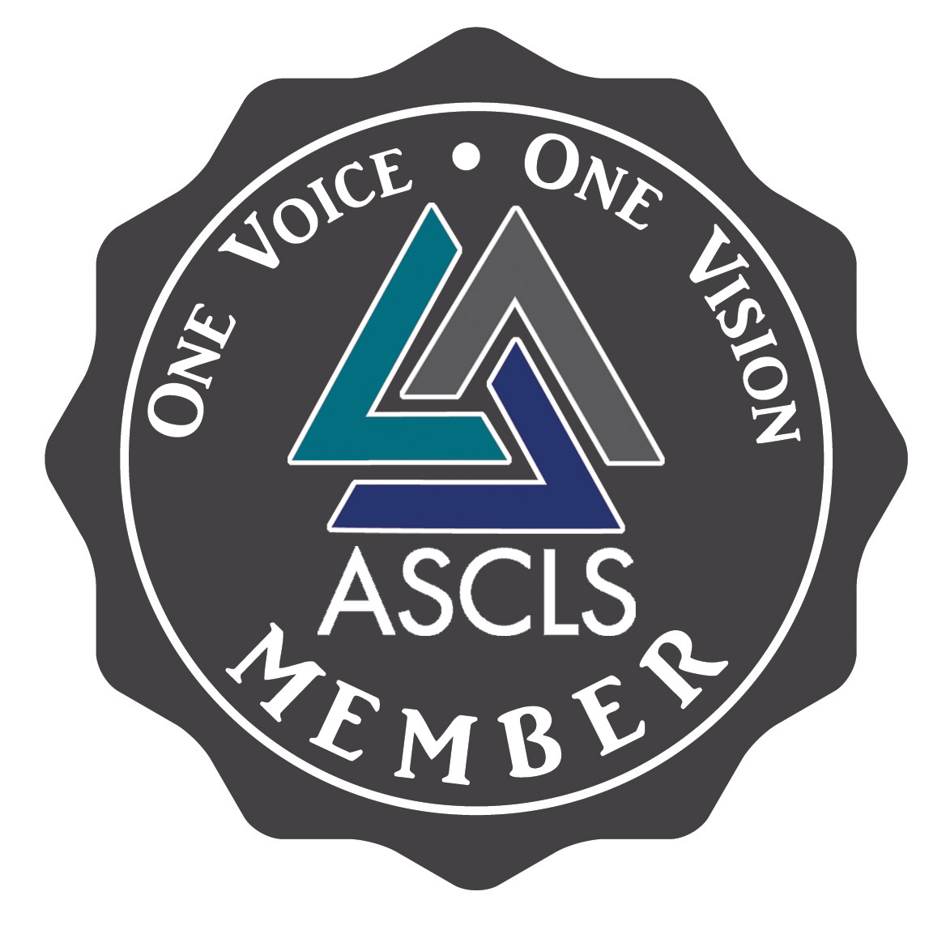

The Cryptoquip is a substitution cipher in which one letter stands for another. If you think that X equals O, it will equal O throughout the puzzle. Single letters, short words and words using an apostrophe give you clues to locating vowels. Solution is by trial and error.

Q**N**DGKCJZM**E**: M**E**RMOG**U**YN YT EJU**N**MUMYEGK BUGUJB GER **M**B YED YT UV**D**

QNYUDME**B** **U**VGU UN**G**EBQYNUB **U**V**W**NYMR **V**YNZYED.

U in the puzzle is a T in the actual word

Unscramble the bold letters to uncover another name for the described protein.

**Help support our Student Forum’s effort to provide travel grants and scholarships to students around the country by purchasing one of these awesome decals! They would be perfect to sell at state meetings or other ASCLS events!**

## **Challenge those Lab Brains!**

If you have an announcement, article or essay you would like to contribute to ***The Culture****,* please feel free to submit it for publication!  
Please send ideas and submissions with the subject line, “NPNMF E-Newsletter Submission” to  
Rebecca Matthews at [matthewsrl@vcu.edu](mailto:matthewsrl@vcu.edu) or Elizabeth LeFors at [libba429@gmail.com](mailto:libba429@gmail.com)



Go to <http://ascls.org/student-fundraiser> to fill out your Decal Request now!

***The Culture*** is published quarterly by the   
ASCLS NPNMF.

**Co-Editors:** Rebecca Matthews and Elizabeth LeFors

Visit the website at <http://www.ascls.org/new-professional-new-member-forum>

**2018 Legislative Symposium**

By: Lacy Faulk

Attending the 2018 Legislative Symposium was a truly wonderful experience. All the societies in the laboratory workforce (ASCLS, CLMA, ASCP, AMT, AGT, and NSH) came together and lobbied to our senators and representatives on issues directly affecting laboratories across the country. The two main issues we discussed were the growing workforce shortage in the clinical laboratory and the flawed data of the Protecting Access to Medicare Act (PAMA). Before attending the legislative symposium, I somewhat knew of these issues, but I did not fully understand how they would impact the places I live and work. Ledge day helped to not only inform me but also showed me how I can help work toward changing the outcome.

On the first day of the symposium, we were all briefed on the issues and how politics worked. The growing crisis in the clinical laboratory is expected to increase. Fifteen percent of all clinical laboratory professionals are expected to retire in the next five years. We have seen a slight increase in the number of accredited programs, but the number of graduates has remained roughly the same for the last five years. The growing population is putting a substantial strain on a profession that is barely growing. We decided to ask Congress to act in three ways on this issue. First, Congress needs to enhance recruitment and retention efforts within the Veterans Health Administration by hosting clinical rotations for MLS and MT students. Second, Congress must authorize funding for programs to ensure training for people seeking to enter the clinical laboratory workforce. Third, we desire the Government Accountability Organization to do a study on the shortage of clinical laboratory personnel and the impact this shortage has on the healthcare system. The main reason I understand and am familiar with PAMA is because last fall we tried to stop the act from passing while it still had flawed data. Unfortunately, it was passed. The law required Centers for Medicare & Medicaid Services (CMS) to establish a market-based payment system for laboratories paid on the Clinical Laboratory Fee Schedule (CLFS). However, the data collected for the fee schedule was mainly from independent laboratories. Hardly any of the data came from hospitals and physician office laboratories, which provide 44% of laboratory services under Medicare. The proposed fee cuts exceed the Congressional Budget Office estimated savings for PAMA by more than 300%. Although cuts need to be made, this big of a cut with skewed data will have a tremendous impact on labs and patient care. This will most likely cause many rural hospital labs to close also causing people to travel to larger hospitals. This could also result in a longer wait for lab results causing a delay in treatment for patients. What we asked of Congress was to revise PAMA and have CMS redo their research. Also, Congress needs to set regulations on CMS’s research to ensure all types of laboratories are included and that geographic areas are represented, including urban and rural regions.

After receiving all the information on the issues, our job was then to lobby to our representatives the next day. That was truly an amazing experience. Most of the meetings were with a representative from his/her office, but we had two very nice surprises. While we were meeting a member of his office, Representative Mike Johnson, walked in and started listening and contributing to the conversation. Almost the exact same thing happened with Representative Ralph Abraham. Overall, every office we went to felt as though the representatives really listened and cared about what we had to say. If they could help us in any way, they would at least try. However, we have to do our part as well. Representative Abraham said it best that the Clinical Laboratory Science community has to come together to address and fight for these issues. We need to not only fight for these issues at the national level but also at the state level. It is going to take all of us to help make change happen for our workforce. Ledge day has me thinking that we should do something equivalent on the state level. It has taught me that there are more things we can do to try to implement change by writing letters, meeting with our local representatives, and knowing our local and state representatives.

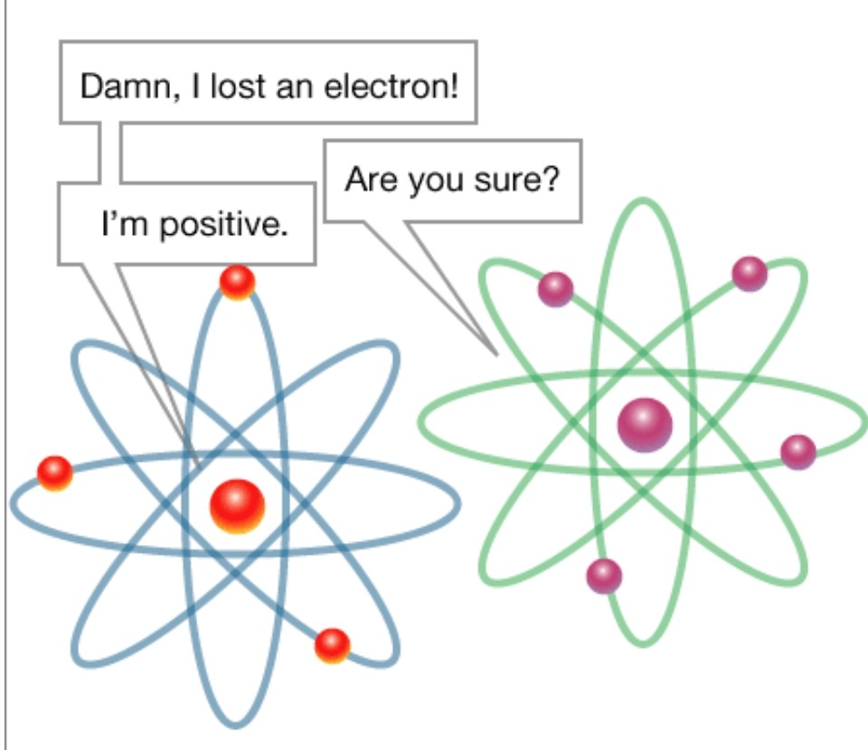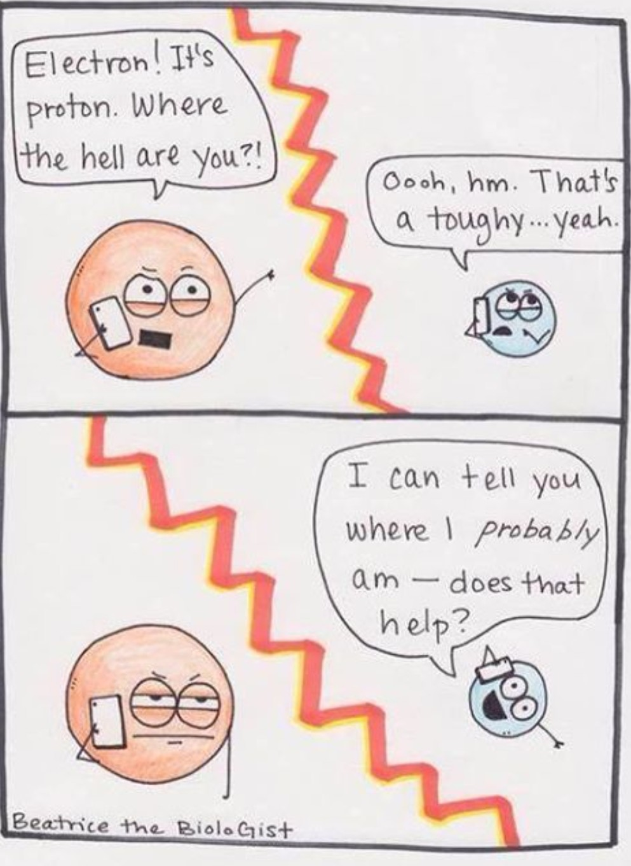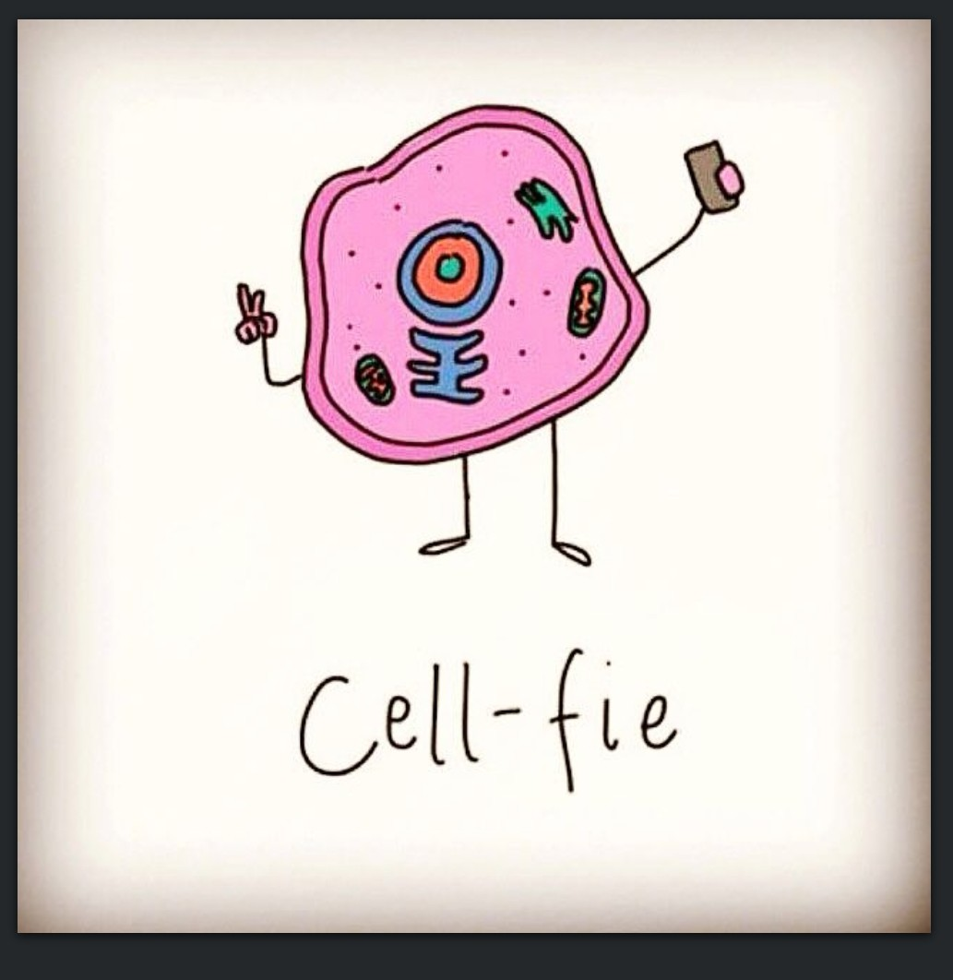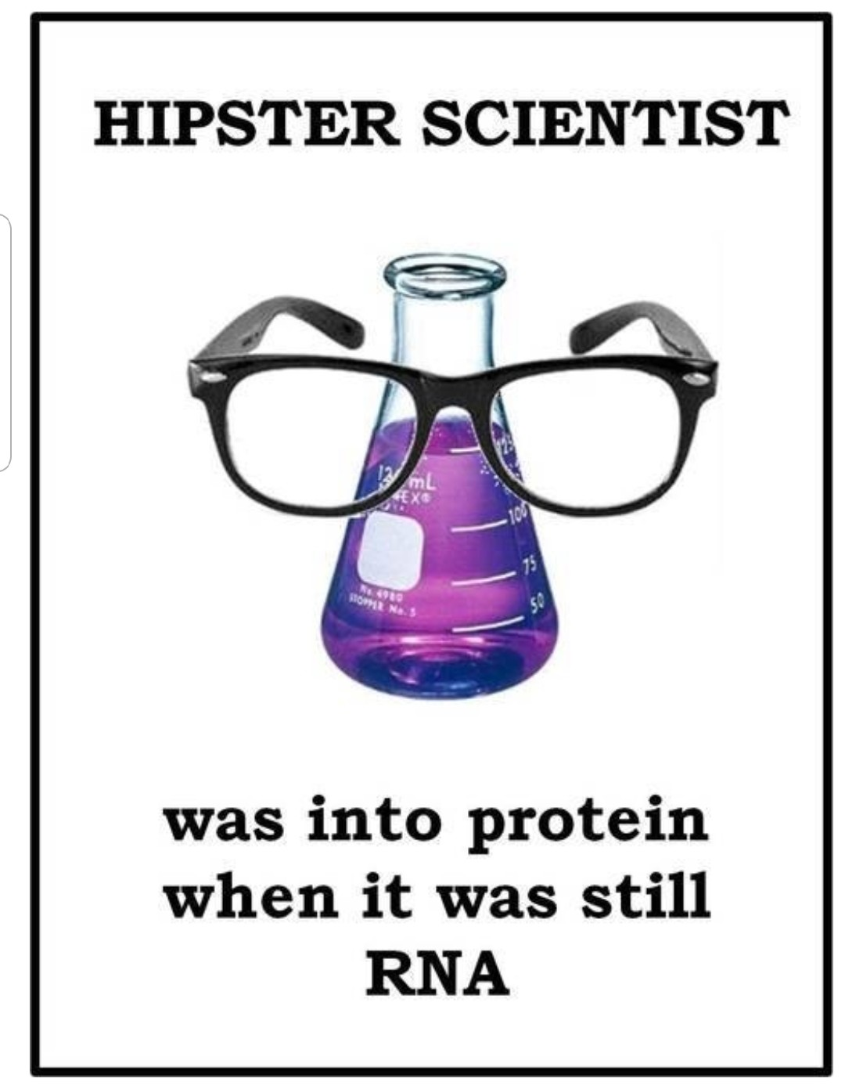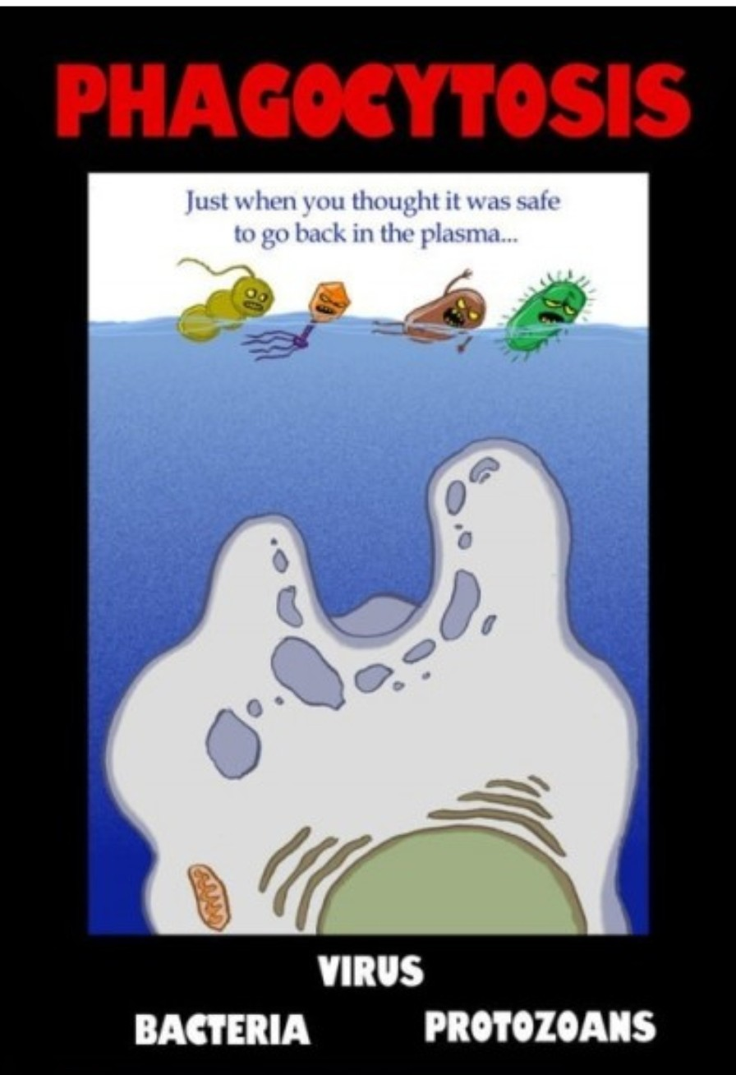

**A Legislative Attendee for Life**

By: Cherika Robertson

As Patrick Cooney stated, “what a great country we live in to be able to voice what we want”. I had never thought of myself as being interested in politics, or much less as a lobbyist. But, my experience at the 2018 Legislative Symposium was both empowering and rewarding. I was fortunate to receive the New Professional New Member Forum (NPNMF) Legislative Symposium Travel Grant. Without this grant, my attendance at this event would not have been possible. And, now I am hopeful to be a legislative symposium attendee for life!

The Legislative Symposium was scheduled for March 19-20 in our nation’s capital, Washington, D.C. The event actually kicked off Sunday, March 18 with a NPNMF and Student Forum mixer. This mixer included dinner at the Hard Times Café, located just a few blocks from the meeting hotel. After dinner, the group headed to Escape Quest, where we had two escape rooms reserved. We divided into two groups, and each group used our problem-solving skills to try to solve the case in order to “escape”. I am happy to report both groups were able to successfully escape! This experience allowed me to reconnect with some members I had previously met at other events, while also allowing the opportunity to establish new relationships.

Image 1. The Student Forum and New Professional New Member Forum kick off Legislative Symposium with a mixer, including dinner and escape room adventures.

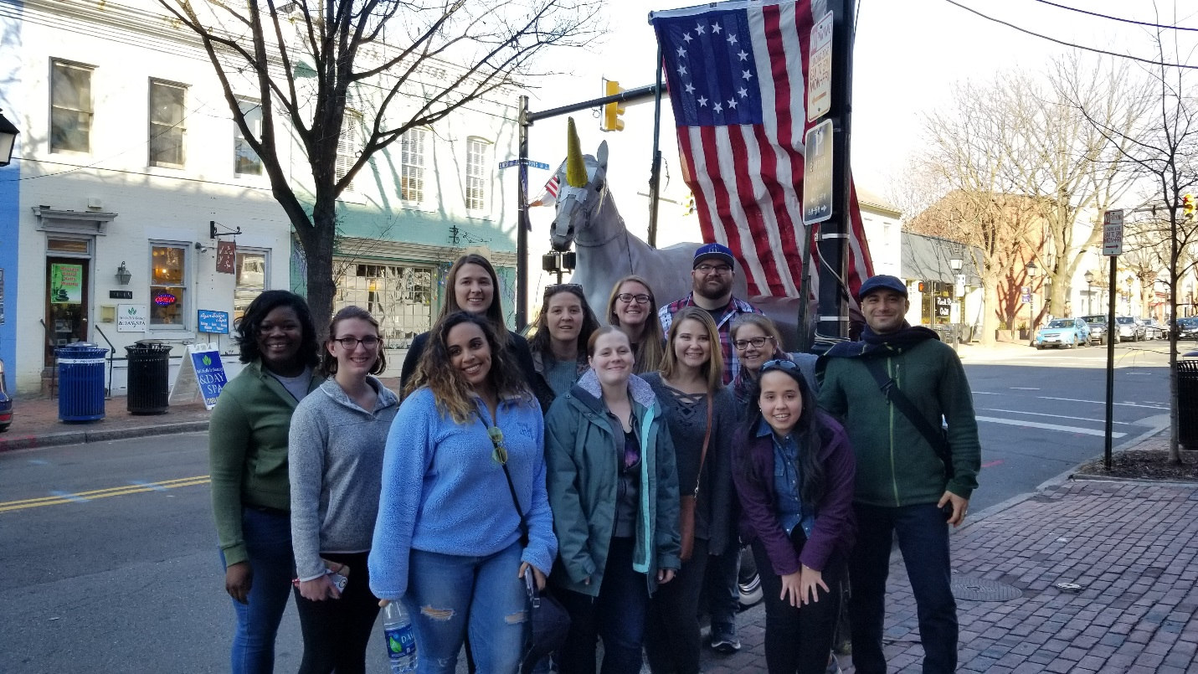

Image 2. Cherika Robertson (right), ASCLS New Professional New Member Forum travel grant recipient, meets with Anna Wilbourn (left), Legislative Assistant and Correspondent for Arkansas 2nd District Representative French Hill, at the 2018 Legislative Symposium held in Washington, D.C. March 19-20.

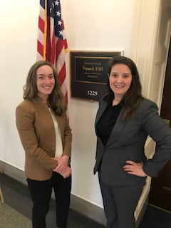

On Monday, March 19, the event officially began with educational sessions describing the issues that needed to be discussed with members of congress, the process of lobbying, and how to effectively communicate with congressional representatives. One important issue included addressing the Protecting Access to Medicare Act (PAMA), which was recently implemented by the Center for Medicare and Medicaid Services (CMS). Under this act, ten percent budget cuts to hospital facilities will occur each year, ultimately having an impact on availability of lab testing at smaller hospitals, physician offices, and nursing homes. Laboratory professionals lobbied for congress to ensure a more valid data collection by CMS to represent all segments of the laboratory market, not just large, high volume laboratories. Also, laboratorians stressed the importance of adjusting the clinical laboratory fee schedule payments that would not result in such a large budget cut for laboratories. Another laboratory issue that was discussed with congress members included the growing workforce shortages. As one can imagine, the budget cuts as a result of PAMA will only worsen this issue. The Bureau of Labor statistics anticipates needed growth of 12,000 new medical laboratory professionals per year to meet growing demand. However, academic programs produced just 6,300 graduates in 2017; a number that has not grown in the last five years. Laboratorians urged congress to enhance recruitment and retention efforts within the Veterans Health Administration by providing resources to host clinical laboratory science programs, to authorize the

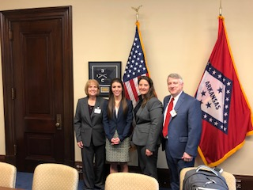

I am excited to share my experience at Legislative Symposium and knowledge of laboratory issues with other laboratory professionals and students. Thank you to the ASCLS NPNMF for making attendance at this event possible. I am already looking forward to attending the 2019 Legislative Symposium.

Image 3. Arkansas Legislative Symposium Delegates Annette Bednar, Cherika Robertson, and Claude Rector have a successful meeting with Abigail Wellborn, Legislative Assistant for Senator Tom Cotton.

funding for a program within the Public Health Service Act to ensure training for those seeking to enter the clinical laboratory workforce, and to authorize the Government Accountability Organization to study the shortage of clinical laboratory personnel and the impact this would have on the healthcare system.

On Tuesday, March 20, the laboratory professionals traveled to the respective locations at capitol hill to meet with senators and representors in an effort to speak up about all of these important issues, and highlight the impact both budget cuts due to PAMA and workforce shortages will ultimately have the health care system and on patient care. I had never met with legislators before, so I was both nervous and excited. I just remembered the advice of Stephanie Noblit and Karen Williams: talk about what you know. And, in order to leave the most impactful impression on the legislators, add a personal story to really drive home the impact of these regulations that we see in our everyday lives. Although the Arkansas delegates did have pre-scheduled meetings with the offices of Arkansas Senators John Boozman and Tom Cotton, and second district representative French Hill, we did not have the opportunity to meet with the actual congress members. Meeting with the actual congress members would have been ideal; however, I did get to meet with each respective congress member’s legislative assistant. At all three of our meetings, the legislative assistants and correspondents were very attentive, asked questions, and took extensive notes. I am confident that our discussions and leave behind materials will be passed on to the senators and representatives.

One thing I realized from my first experience at Legislative Symposium is that I can use my voice, knowledge and experience to make a difference. I highly encourage all laboratory professionals to remain educated on important legislation issues that will have an impact on our profession, the health care system, and ultimately patient care. One way to do this is to not only become a member of ASCLS, but be active and informed. If we don’t advocate for ourselves, who will?

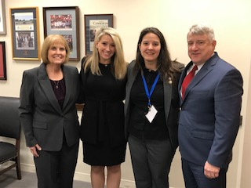

Image 4. Arkansas Legislative Symposium Delegates Annette Bednar, Cherika Robertson, and Claude Rector have a successful meeting with Jennifer Humphrey, Legislative Assistant for Senator John Boozman.

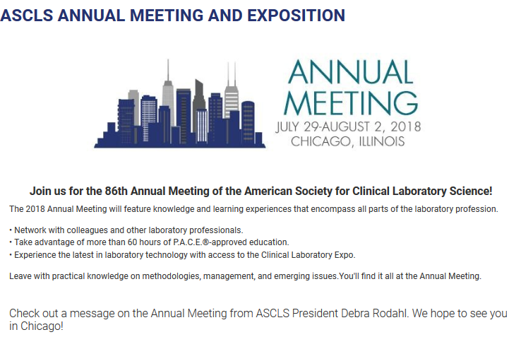

**\*\* Be sure to register before June 1st to get the Early Bird Discount! For registration, accommodations, and more information go to** <http://www.ascls.org/education-meetings/annual-meeting>**. Stay tuned about travel grant opportunities!**